READ ME

YouTube Link - <https://youtu.be/b48T4ZKGoDI>

Empowering the Nation Web and Mobile App

**Project Overview**

Empowering the Nation has asked us to develop this product for the local SME that upskills domestic workers and gardeners. We have created a mobile application and website that enables domestic workers and gardeners to view courses, calculate fees with discounts, and contact the organization to enroll.

**Features/Functionalities**

* Navigation
* Responsive Layouts
* Quick Links
* Display Six-Month courses
* Display Six-Weeks courses
* Course Details
* Fee Calculator
* Contact Information
* Search Engine Optimization
* Error Handling

**Tools**

**Frontend –** Android Studio Kotlin for mobile app, and HTML, CSS with VS code for the web.

**Backend:** Firebase or equivalent for form handling and data storage.

**Design:** User Interface (UI) created using Canva.

**Version Control:** GitHub repository for collaboration and submission.

**App Logging**

**toggleSelection() Method**

Handles the selection/deselection of course and keeps track of them for calculations.

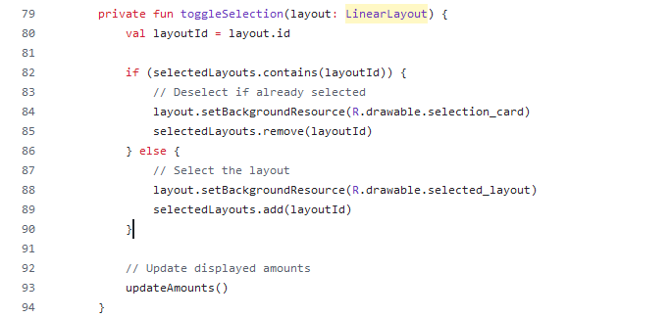

**updateAmounts() Function**

Calculates and displays the total price of selected courses, including discount and tax.

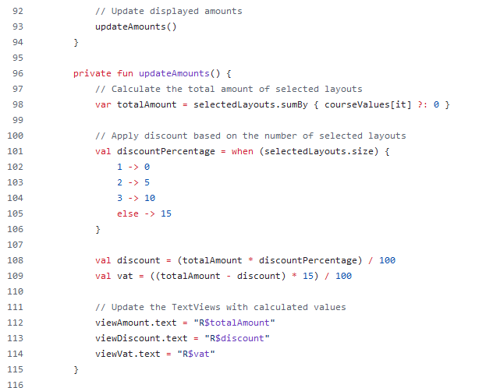

**calculateTotal() Function**

Calculates and displays the final payable amount.

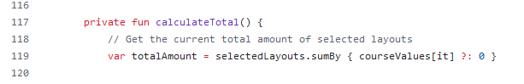

**Web Log**

* The selected courses' values will later be used to calculate the total fee.
* Discount and other operations (not shown in this snippet) will be applied based on the selected courses.

// Calculate total fee on button click

document.getElementById('calculateBtn').addEventListener('click', function () {

const courses = document.querySelectorAll('input[name="course"]:checked');

let fullAmount = 0;

let discount = 0;

* to compute the total cost of the selected courses before any discounts or taxes are applied.
* This forms the base value for further calculations, such as applying discounts or VAT.

// Calculate the full amount of selected courses

courses.forEach(function(course) {

fullAmount += parseFloat(course.value);

});

* Calculates the total cost of selected courses, including discounts and taxes.
* Offers incentives based on the number of courses selected.
* Adds VAT to simulate real-world pricing structures.
* Prepares discountAmount, vatAmount, and finalTotal values for display or further use.

// Apply discount based on the number of selected courses

const selectedCoursesCount = courses.length;

if (selectedCoursesCount === 2) {

discount = 0.05; // 5% discount

} else if (selectedCoursesCount === 3) {

discount = 0.10; // 10% discount

} else if (selectedCoursesCount > 3) {

discount = 0.15; // 15% discount

}

const discountAmount = fullAmount * discount;

const discountedTotal = fullAmount - discountAmount;

// Apply VAT (15%)

const vat = 0.15;

const vatAmount = discountedTotal * vat;

const finalTotal = discountedTotal + vatAmount;

Shows the user the calculated breakdown of the total fee.

// Display the amounts

document.getElementById('fullAmount').textContent = fullAmount.toFixed(2);

document.getElementById('discountAmount').textContent = discountAmount.toFixed(2);

document.getElementById('vatAmount').textContent = vatAmount.toFixed(2);

document.getElementById('totalAmount').textContent = finalTotal.toFixed(2);

});

* Prevents the default submission and allows for controlled behavior, such as validating inputs or processing data before redirection.
* Sends the user to a confirmation or success page after form submission.
* Provides a clear endpoint (the success page) for the user's interaction with the form.

// Handle form submission and redirect to the success page

document.getElementById('courseForm').addEventListener('submit', function (event) {

event.preventDefault(); // Prevent form submission

window.location.href = "success.html"; // Redirect to the success page

});

# Bibliography

1. The IIE. 2024. Mobile App Scripting [MAST5112/d/p/w]. MODULE MANUAL 2024. The Independent Institute of Education: Unpublished.

2. The IIE. 2024. INTRODUCTION TO PROGRAMMING LOGIC [MODULE

MANUAL]. The Independent Institute of Education: Unpublished.

3. Canva. 2024. Canva.com

Available at: <https://www.canva.com/> [Accessed: 17 August 2024].

4. Perplexity.ai. 2024. Perplexity (version 2.25.1). [Large language model].

Available at: <https://www.perplexity.ai/> [Accessed: 17 August 2024].

5. Robles, M. M.2012. ‘Executive Perceptions of the Top 10 Soft Skills Needed in Today’s Workplace’, Business Communication Quarterly, 75(4), pp. 453–465. doi: 10.1177/1080569912460400